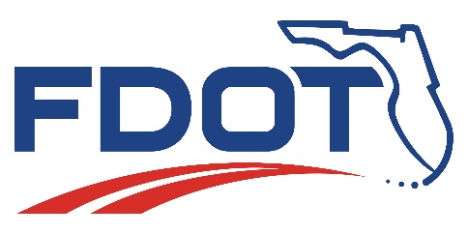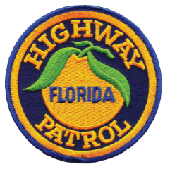

September 8, 2017 | Dick Kane, 850-414-4595  FDOT Communications Director  dick.kane@dot.state.fl.us  Beth Frady, 850-617-3102  Cell: 850-694-9313  FLHSMV Communications Director  bethfrady@flhsmv.gov
Media Advisory

FDOT, FHP Implements Limited Emergency Shoulder Use (ESU) Plan for Hurricane Irma on I-75 at Wildwood to the Georgia State Line
There is no contraflow or one-way operation in use on Florida state roadways

Tallahassee - The Florida Department of Transportation (FDOT), working with the Florida Highway Patrol (FHP), has implemented a limited Emergency Shoulder Use (ESU) plan for Hurricane Irma evacuations on I-75 at Wildwood to the Georgia state line. Motorists should only use the left shoulder when directed by law enforcement and highway signs.

- There is no contraflow or one-way operation in use on Florida state roadways
- No other state roadways are currently approved for shoulder use
- Although there are heavy pockets of evacuation traffic in some areas; traffic is flowing on this section of roadway
- Law enforcement urges motorists to use caution when driving on the shoulder – right shoulder use is prohibited
- FDOT has 13 Traffic Management Centers where hundreds of DOT workers are monitoring traffic cameras 24/7 to ensure traffic flows continue and evacuations proceed without interruption.

NOTE: Contraflow blocks essential southbound lanes needed to bring supplies to shelters and families in the southern part of the state. Contraflow also inhibits emergency vehicles from reaching people in need, and removes law enforcement from critical life safety tasks.

www.fdot.gov

